Fayrouz Hadi
790:391 Data Science in Political Science
Professor Katherine McCabe
December 16, 2021
Final Project

The Trend of Terrorism in the U.S. from 1980 to 2019 by Group Origin

Introduction:

In our analysis, we are seeking to examine whether attacks by domestic terrorist groups (DTO) are on the rise compared to foreign terrorist groups (FTO) after 9/11 attacks. Given the immensely polarized politics of the United States in recent years, we anticipate a rise in nationalist and anti-nationalist sentiments, catalyzing the growth of domestic fringe groups, which are more likely to grow due to the fervent contestation of extreme policies on both political spectrums. We relied on the Global Terrorism Database (GTD) for our descriptive method to analyze whether attacks by domestic groups exceed those by foreign groups before and after 9/11 over a defined time frame (1980-2019).
We displayed the results to give a sense of the progress of terrorism over the year, and we proceeded to perform a mean comparison afterward. The results indicate a slight decrease (8%) in attacks by FTOs after 2001; however, our visuals elucidate that attacks by DTOs have always exceeded attacks by FTOs on a larger scale. Our findings bring about a more focused and elaborate analysis of the groups involved in the attacks to produce adequate and efficient counter-terrorism strategies. Our research question is broadly centered around the trend of terrorism is terms of domestic and foreign terrorist organizations during the selected time period, but our results stir inquisitiveness to study the groups involved in recent attacks even more closely.
Background:

Our research question frames our analysis into two parts: the first one examines the trend of terrorism on a broader scale, and the second seeks to unveil the change in this trend, particularly attacks by FTOs compared to attacks by DTOs since 1980. Although we acknowledge that foreign attacks in the U.S. have had far more devastating effects causing a total reform on a federal level (e.g., restructuring of the Intelligence Community after 9/11), we believe that domestic terrorism can have similar drastic effects if not adequately countered. This question was formulated following the House Committee hearing minutes in 2019 on the matter of domestic terrorism, wherein members voiced their concern on the rise of domestic terrorism in recent years, stating that “in the last 2 years, there have been more domestic terrorism-related arrests than international terrorist-related arrests. Last year, nearly all extremism-related murders in the United States were committed by right-wing domestic terrorists.” ( Congress 116th, 2019, p.2).
On our end, we foresee a spike in domestic attacks after 9/11, given the ambiguity of the U.S. political scene and the shift in counter-terrorism policies to international terrorism after 9/11. We intend to explore the number of attacks by FTOs and DTOs in two-time frames to conclude whether there has been a change in the origin of perpetrators after the 9/11 attacks.

Data and Approach:

The data set was extracted from the Global Terrorism Data base. It contains information on more than 200,000 terrorist attacks, 95,000 bombings, 20,000 assassinations, and 15,000 kidnappings and hostage events from 1970 up until 2019 (GTD, 2019), collected over 4 phases of collection. The entire data set contains 81 variables and 201183 observations; we relied on the variables below for our analysis:

Variable Name | Description
Gname  iyear  Country_text | The name of the group that perpetrated the attack.  Years from 1970 to 2019 during which the attacks were recorded.  Name variable; This field identifies the country or location where the incident occurred. Separatist regions, such as Kashmir, Chechnya, South Ossetia, Transnistria, or Republic of Cabinda, are coded as part of the “home” country. In the case where the country in which an incident occurred cannot be identified, it is coded as “Unknown.” (GTD, 18)

Our analysis is strictly based on attacks in the U.S. from 1980 to 2019. We created two subset of data to compare attacks before and after 9/11 assigned respectively as follows: Before911 & After911. In order to reduce skewness, we created approximately equal time intervals for both subsets by excluding data before 1980 in the first subset. In the next step of our approach, we used the table command for both subsets, extracting for “iyear”, and obtained the number of attacks in each year. We created two vectors, x and y, containing the results which we displayed in a bar plot as an initial visualisation of the terrorism trend since 1980 up until 2019.
We conducted a mean comparison between the number of attacks by FTOs and DTOs, by creating a vector (FTO) combining all foreign groups of the group name variable “gname”, and creating a conditional statement where we recorded the “gname” variable into numeric values assigned for each group: 0 for FTO, and 1 for DTO (groups not in the foreign groups vector).
To support our analysis, we created a visual using the new variable in which we compared attacks and groups before 9/11 and after 9/11.

Results:

Figure 1
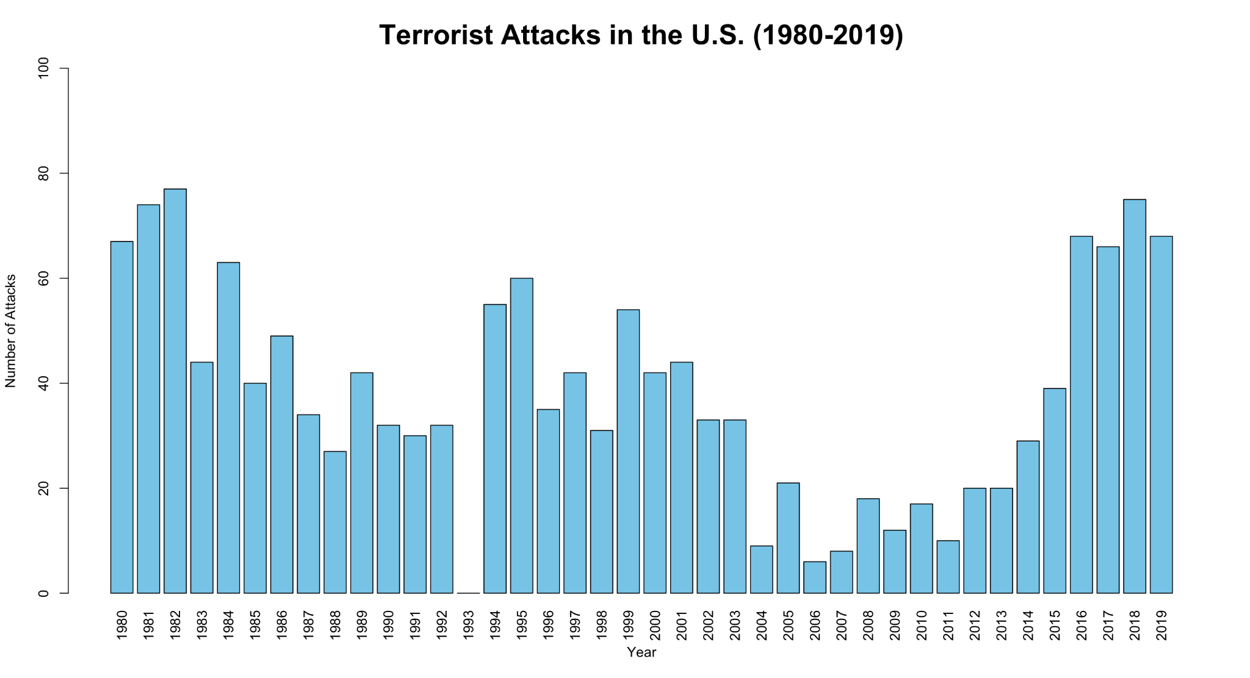

The bar plot indicates a fluctuating trend in terorism in the U.S., with more attacks in the early 80s increasing again in 2016. The results prompt us to examine more closely the factors that may have been contributing to this fluctuation and what may have caused the sudden increase in attacks (e.g. change in political landscape) in the future. The means comparaison results of our new variable were as follow:
> mean(Before911$FTO)
[1] 0.9043011
> mean(after911$FTO)
[1] 0.9883139
> mean(Before911$FTO)-mean(after911$FTO)
[1] -0.08401278
We conclude that there is a an 8% decrease in attacks by foreign terrorist groups after 9/11. However, given the mean of both groups in both time frames, we conclude that there has always been a prevalent number of attacks by domestic groups over the selected period of time compared to foreign groups, as shown in figure 2 below:
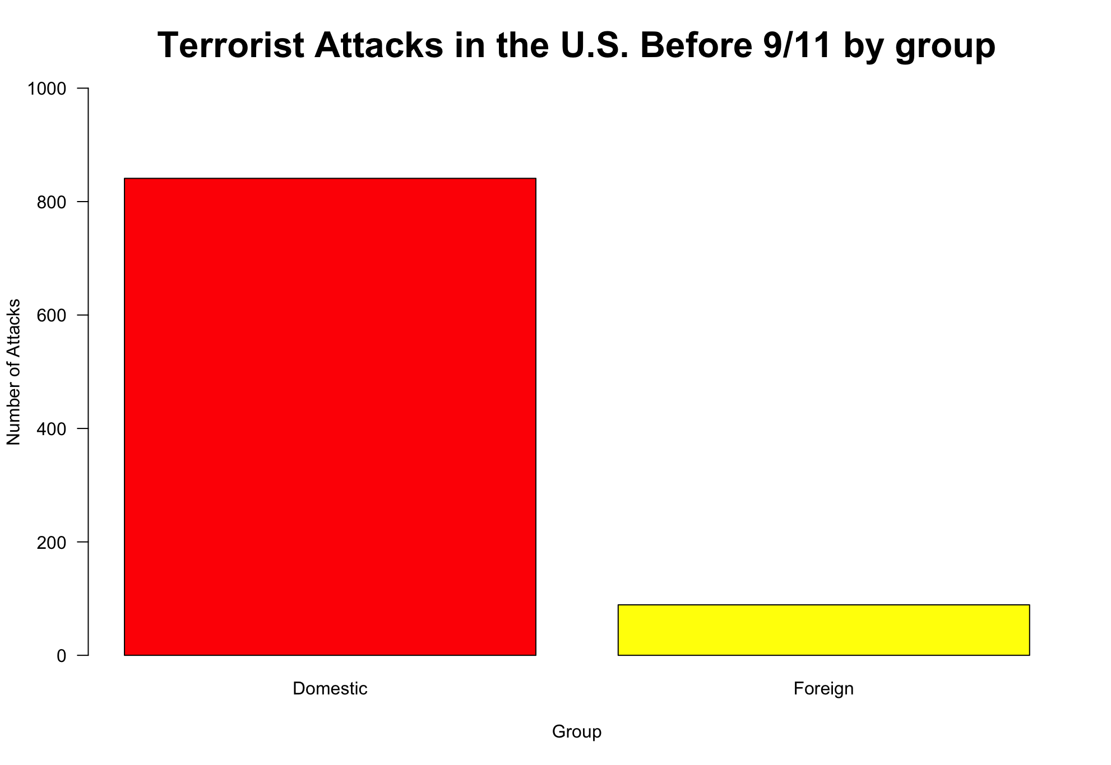
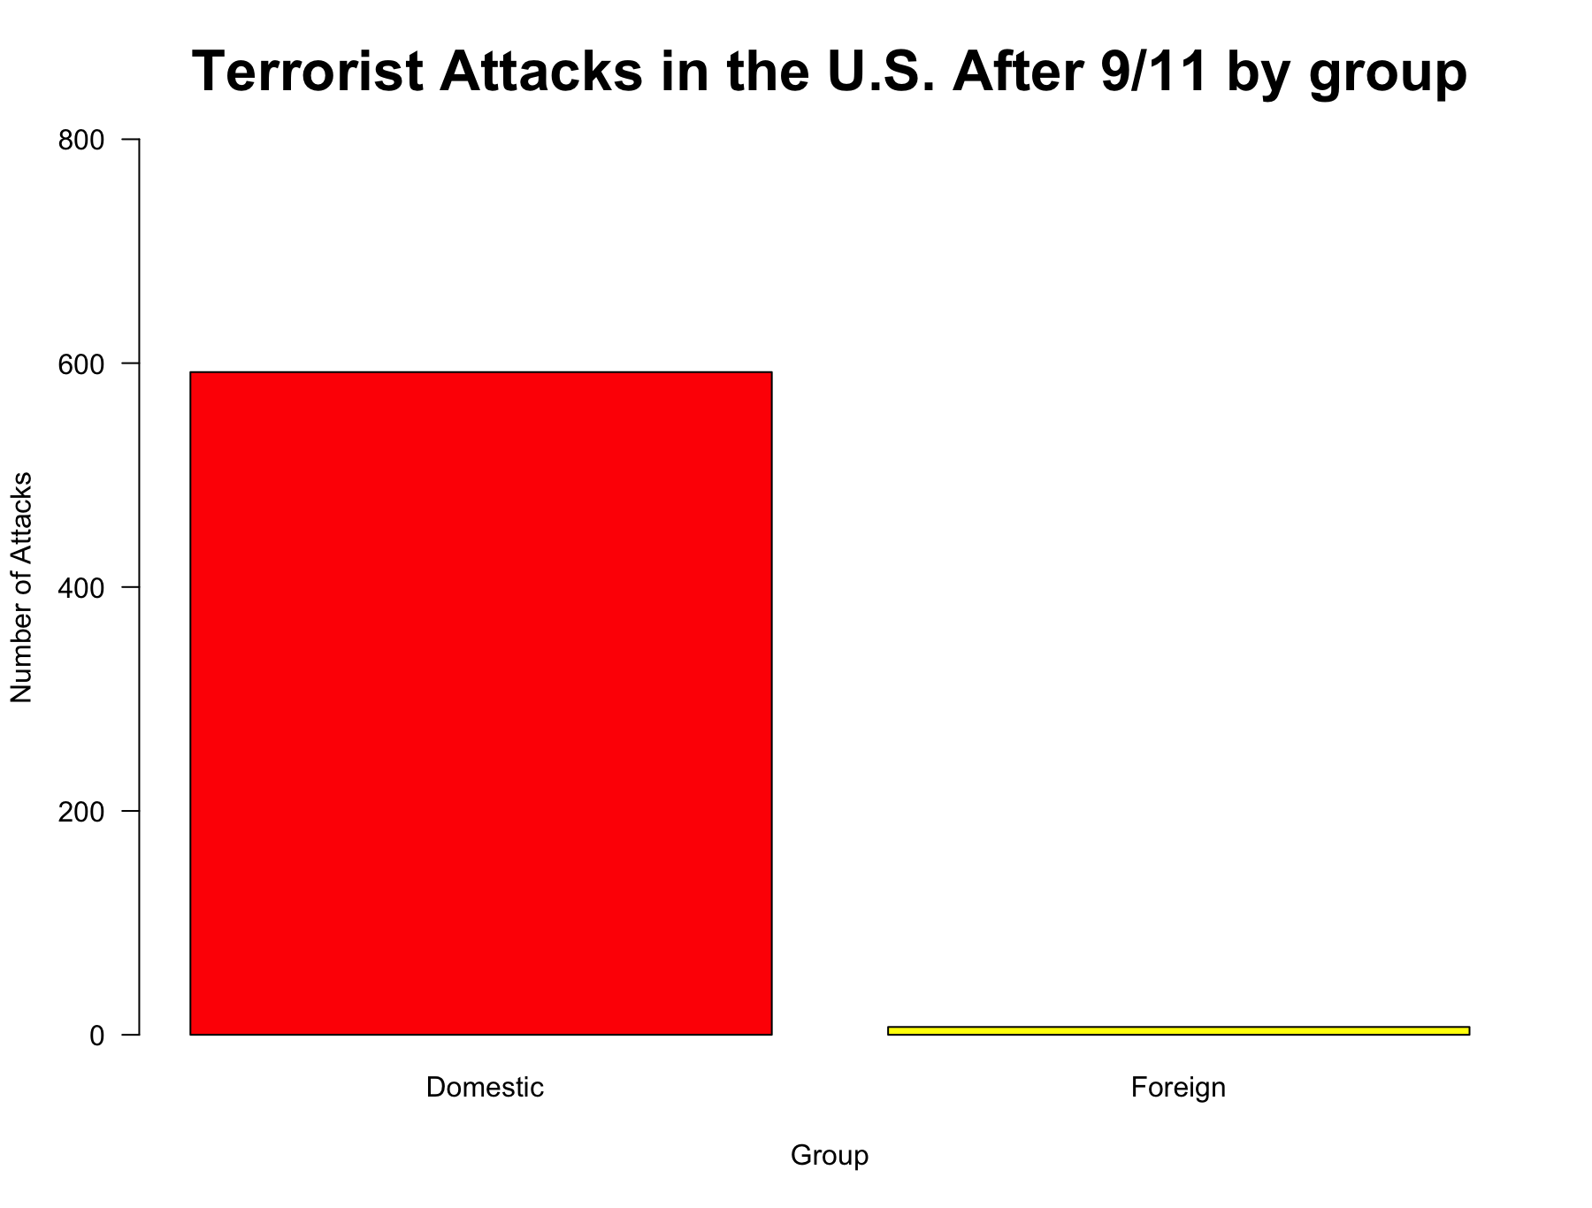
Figure 2

Conclusion:
Our research question sought to determine whether attacks by DTOs exceeded attacks by FTOs after the 9/11 attacks. We found that after the 9/11 attacks, foreign terrorist groups stroke 8% less than before 9/11, but domestic attacks have remained predominant over the last two decades. Our findings do not match our expectations. However, they substantiate our theory that domestic terrorist attacks are a matter of urgent concern, given the large scale showcased in our visuals.
The spike in terrorist attacks the period from 2016 to 2019, observed in figure 1, prompts us to examine the ideology and narrative of domestic groups involved in the attacks for a future analysis. We have noticed recurrent attacks staged by the following groups:
- White supremacists
- Jihadi-inspired extremists
- Anti-Muslim extremists
- Anti police extremists
- Conspiracy theory extremists
The actual conundrum of domestic terrorism can culminate into more extreme trends such as the coalition between domestic and terrorist organizations if not properly tackled. According to a recent report by the New Jersey Office of Homeland Security and Preparedness (NJOHSP), FTOs are swarming across social media networks ​​, capitalizing on the loosening of COVID-19 restrictions, exploiting the current domestic turmoil and anti-government sentiments, and spreading disinformation and conspiracy theories to garner support and motivate homegrown violent extremists (HVEs) to conduct attacks (NJOHSP, 2021).

References
New Jersey Office of Homeland Security and Preparedness (NJOHSP). (2021, June 28).
Analysis: FTO Propaganda Exaggerates US Domestic Issues. Extracted from: https://www.njhomelandsecurity.gov/analysis/fto-propaganda-exaggerates-us-domestic-issues

START (National Consortium for the Study of Terrorism and Responses to Terrorism). (2021,
August). Global Terrorism Database (GTD). University of Maryland. Extracted from: https://www.start.umd.edu/gtd

116th Congress. (2021, December 16). Confronting the Rise of Domestic Terrorism in the
Homeland. Extracted from:
https://www.congress.gov/event/116th-congress/house-event/LC64275/text

